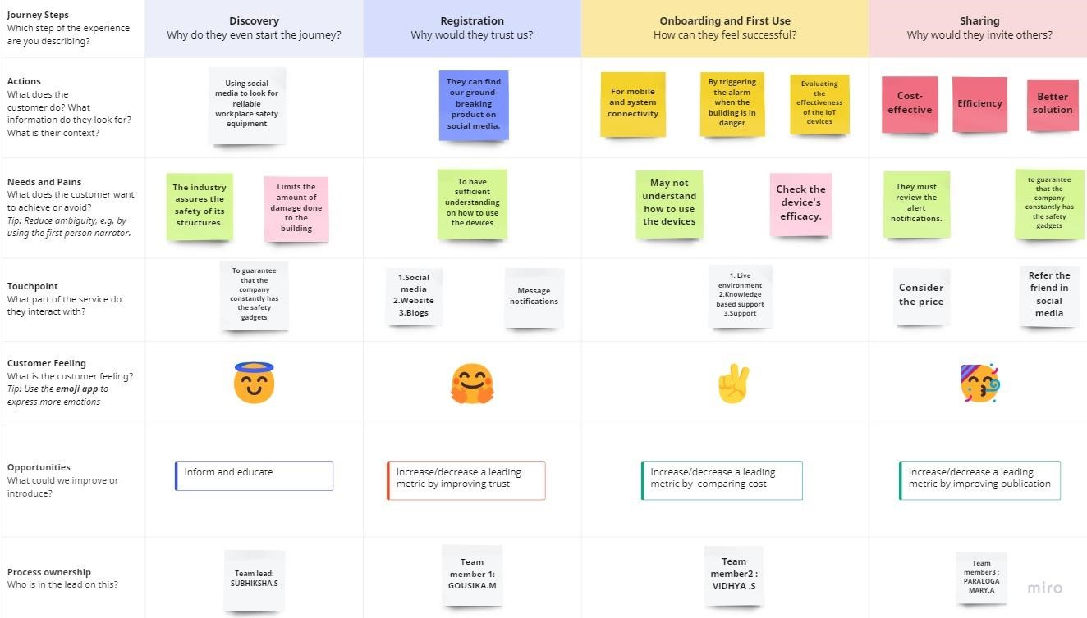

**CUSTOMER JOURNEY MAP**

**S**

**TEAM ID: PNT2022TMID36766**